LGIDA Sustainable Infrastructure Guidelines: Case Study

Introduction
The Local Government Infrastructure Design Association (LGIDA) is a group of 41 Victorian Councils that have adopted a common infrastructure standard titled the Infrastructure Design Manual (IDM). A supplement to the IDM, the Sustainable Infrastructure Guidelines, was developed by the LGIDA in 2012 with the aim of providing advice on alternative design considerations and materials that deliver more sustainable infrastructure through:
- Using recycled materials
- Reducing the carbon footprint of projects
- Reducing maintenance and operating costs
- Utilising water in more efficient ways
- Utilising materials from sustainable sources
The LGIDA Group then selected three demonstration projects that were to be based on the Guidelines and commissioned a case study to:
- Develop key performance indicators to assess the effectiveness of the application of the Guidelines
- Document the design, construction and delivery of the demonstration projects
- Compare the sustainable design and construction approach for each project with a more conventional approach assessing cost, availability of materials, constructability and total carbon emissions
The three projects were:
- Steam Packet Place – a laneway in the City of Greater Geelong
- Grant Street Footpath – a footpath and streetscape project in Forrest (Colac Otway Shire)
- Pavement rehabilitations using foamed bitumen asphalt (FoamMix) at Grange Park Drive and Townsend Road in the City of Greater Geelong.
Preparation of the Guidelines and the case study report were funded with the support of the Victorian Government under the Victorian Adaptation and Sustainability Partnership. The City of Greater Geelong and the Colac Otway Shire were the lead agencies on behalf of the IDM Group for the funding grant. The project was administered by the City of Greater Geelong.

Steampacket Place

Description of Works
The works included the removal of existing pavement and construction of new pavement, drainage, street furniture, lighting and landscaping for the laneway which carries pedestrian and vehicular traffic.

Pavement
A new reinforced concrete pavement was constructed using low carbon concrete with Eco-reo™ reinforcement. The sub base layer beneath the concrete pavement was recycled crushed concrete.

Drainage
A mulit-layered biofilter and retention system was constructed in place of a concrete kerb. The layers consisted of a vegetated layer, overlying a filter media, transition layer and drainage layer with a perforated collection pipe that discharged into the existing stormwater system.
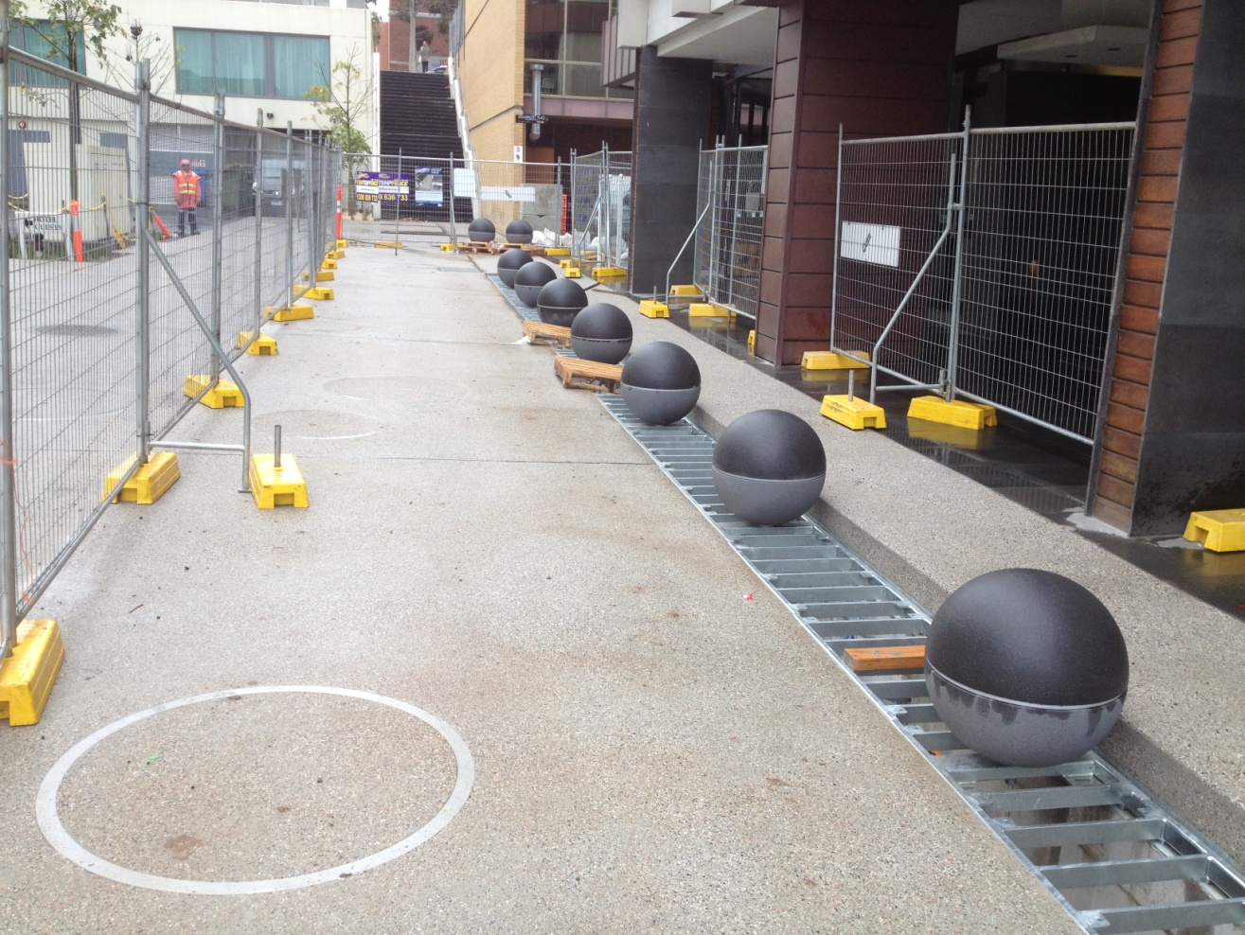
Bioretention system during construction
A central raingarden pit was also provided to collect storm water runoff and filter it through a multilayered soil system, eventually discharging excess water to the existing drainage system. Irrigation for these gardens is to be sourced from captured runoff water.
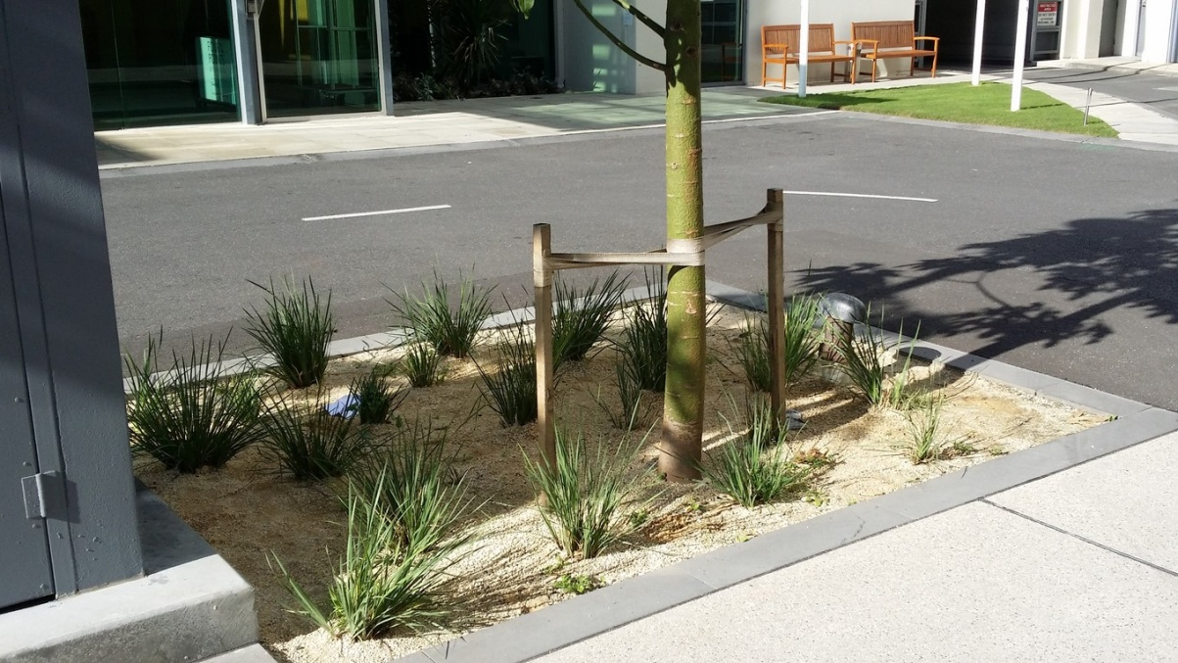
Completed rain garden

Landscaping
Eight trees (Brachychiton acerifolius) and 31m² of tufting plants (Patersonia occidentalis) were planted.
The plants will capture carbon dioxide and therefore contribute to carbon reduction in the atmosphere. They also add aesthetics and the garden area beneath the trees reduces impervious areas with corresponding reduction in stormwater runoff and also aiding groundwater recharge.

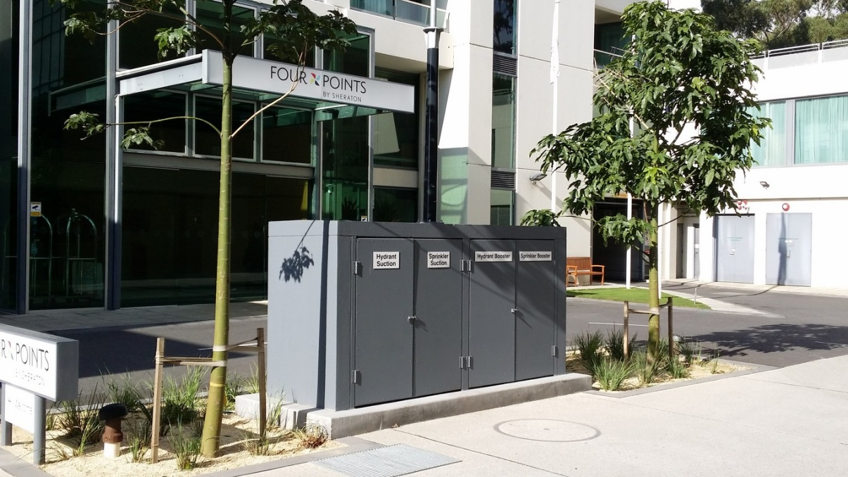
Brachychiton acerifolius and tufting plants in rain garden

Key Performance Indicators
Key Performance Indicators (KPI) as listed in Table 1 was developed for all projects.
Table 1: KPIs Steampacket Place
KPI | Evaluation Criteria
Sustainable Infrastructure Checklist | Evaluate the project against the checklist
Carbon footprint | Assess carbon footprint for the project and compare with a conventional approach
Cost | Costs of the project compared with a conventional approach
Constructability | Ease of construction and use of alternative materials and designs
Availability of materials | Were specified alternative materials readily available
Design initiatives | Identify implementation of specific sustainable design initiatives from the Sustainable Infrastructure Guidelines
Use of sustainable/alternative materials | % use of sustainable/alternative materials
Net flora increase | Identify if there is a net increase in
Drainage | Determine % reduction in run-off and pollutants
Maintenance | Identify any maintenance concerns
Appearance/aesthetics | Determine if the Sustainable Design approach has resulted in enhanced appearance/aesthetics

Sustainable Infrastructure Checklist
A Sustainable Infrastructure Checklist, which was developed under the Sustainable Infrastructure Guidelines, was completed for this project and a rating of 3 stars out of 5 was achieved.

Carbon Footprint
The carbon footprint of the project was compared with a “conventional” design for the two main elements of concrete pavement and drainage system.

Concrete Pavement
The conventional alternative to the low carbon concrete pavement is a GP cement concrete with crushed rock and natural sand aggregate. Table 2 compares the mixes.
Table 2: Concrete Mix Comparison
 | Low Carbon Concrete | Conventional Concrete
Cementitious  Materials | Quantity (kg/m³) | Quantity (kg/m³)
General Portland Cement | 253.75 | 350
Slag | 68.75 | 0
Fly ash | 27.5 | 0
Coarse and Fine Aggregates | Quantity (kg/m³) | Quantity (kg/m³)
Natural | 1030 | 1840
Recycled | 710 | 0
Waste Sand | 100 | 0
Low carbon concrete has a 27.5% lower GP cement content than conventional concrete through the use of slag and fly ash which are both waste materials created during other processes and if not reused will be sent to landfill and accordingly have very low embodied carbon content.
Aggregate for the low carbon concrete contains recycled bricks, recycled crushed concrete and manufactured sand, which are all waste products that would otherwise be sent to landfill and reduce the amount of natural gravels and sands in the concrete mix by 44%.
The low carbon concrete pavement also used Eco-Reo™ which has the same engineering properties as conventional reinforcement and is therefore a 1:1 quantity comparison.
The new pavement was placed on a recycled crushed concrete base which replaced crushed rock or natural gravel.
Table 3: Concrete Pavement Emission Comparison
 | Low Carbon Concrete | Conventional Concrete
Concrete | Emissions (kgCO₂) | Emissions (kgCO₂)
Cementitious Material | 19060 | 26290
Natural Aggregates | 1980 | 3538
Recycled Aggregates | 1160 | 0
Reinforcing | 2759 | 2904
TOTAL | 24959 | 32732
Table 4: Sub base Emission Comparison
 | Crushed Concrete Base | Conventional Base
Gravel Subbase | Emissions (kgCO₂) | Emissions (kgCO₂)
Natural Aggregates |  | 2346
Recycled Aggregates | 1748
TOTAL | 1748 | 2346

Drainage System
The drainage system follows Water Sensitive Urban Design principles. A conventional approach would utilise kerb and gutter to collect runoff and direct it to a pit rather than the bioretention trench. The kerb and gutter solution can only be compared to the bioretention in terms of moving the water from point A to point B, and does not provide a reduction in the runoff volume during/after rain events or a reduction in pollutant levels.
The bioretention trench has a cross sectional area of 0.54m² and contains around 17m³ of concrete. It also includes 10.4m³ of drainage filter materials and PVC pipes. By comparison the kerb has a cross-sectional area of 0.12m² and contains around 4m³ of concrete The bioretention pit option has a higher carbon footprint than the kerb option but provides water quality benefits that cannot be achieved with kerb and gutter.
Table 5: Drainage Emission Comparison
 | Bioretention | K&G
Concrete | Emissions (kgCO₂) | Emissions (kgCO₂)
Cementitious Material | 3777 | 1158
Natural Aggregates | 392 | 156
Recycled Aggregates | 230 | 0
Reinforcement Bar | 547 | 128
TOTAL | 4946 | 1441

Cost Analysis
For cost comparison purposes the low carbon concrete was replaced with conventional concrete and the bioretention system was replaced with kerb and gutter. The quoted price for the project was $289,035. The conventional design was estimated to cost $261,314.

Constructability
The Contractor highlighted the following points with respect to constructability:
- The low carbon concrete and Eco-Reo reinforcement acted identically to conventional concrete and reinforcement
- The recycled crushed concrete sub base had excellent workability and was readily compacted
- The biofilter was the most difficult and time consuming element to construct but was well within the capabilities of workers using typical equipment and techniques

Availability of Materials
All required materials were readily available from local suppliers in Geelong.
The sand filter media filter for the bioretention trench had to meet strict grading requirement which could not be met from the supplier’s standard production runs and required additional processing to meet the specification.

Use of Sustainable/Alternative Materials
The percentage use of sustainable/alternative materials is summarised as follows:
- The proportion of slag and fly ash in the concrete reduces the GP cement content by 27.5%
- The recycled bricks, recycled crushed concrete and manufactured sand in the concrete reduce the amount of virgin aggregates by 44%
- The crushed concrete subbase is entirely a waste material and reduces the amount of virgin aggregates for this element by 100%

Net Flora Increase
Eight trees (Brachychiton acerifolius) and 31m² of tufting plants (Patersonia occidentalis) were planted providing a net flora increase when compared with the previous conditions.

Drainage
The bioretention trench was analysed under 10, 50 and 100 year storm events. During a 10 year ARI event the total runoff can be accommodated within the filter media and outflow is limited to 1.2 L/s. During higher return periods, the runoff volume exceeds the available storage and inflow to the stormwater system occurs. The bioretention system also reduces peak runoff considerably as shown in Table 6.
Table 6: Reduction of peak outflows
ARI (years) | Peak runoff (L/s) | Estimated peak inflow to stormwater system (L/s) | Percentage reduction (%)
10 | 19.1 | 1.2 | 94
50 | 28.8 | 20.4 | 29
100 | 33.7 | 26.5 | 21
The reduction in pollutants due to the bioretention is shown in Table 7. All are within target reduction levels proposed by EPA Victoria.
Table 7: Pollutant reduction rates
Pollutant | Percentage reduction (%) | Target reduction (%)
Suspended solids (SS) | 97 | 80
Total Phosphorous (TP) | 86 | 45
Total Nitrogen (TN) | 47 | 45

Maintenance
The most critical maintenance item is the bioretention trench and healthy growth of vegetation is key to maintaining the porosity of the filter media. Ongoing maintenance will include litter removal which will require removal of the grate. Pruning of plants will also be required at regular intervals.

Appearance/aesthetics
The inclusion of planted trees, the bioretention trench and other landscaping elements has improved the general appearance of the laneway by providing lighter neutral tones accompanied by green natural elements and creative lighting. It is a useable space and still serves its primary purpose of pedestrian and vehicular access.
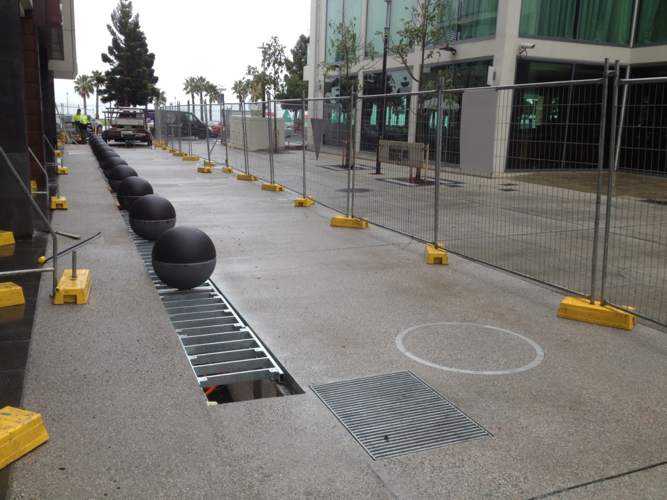
Near on completion Drainage System

Findings
The overall carbon emissions were reduced by 4,900kgCO₂ when the sustainable design was adopted. The low carbon concrete reduced the total emissions by 8,400kgCO₂, however, the bioretention trench required more concrete than a standard kerb and channel which reduced these savings by 3,500kgCO₂. The benefit of the drainage works were not carbon reduction but improvement of stormwater quality and runoff volume.
The overall cost was increased by $27,721 when the sustainable design was adopted. This is due to the concrete mix and also the landscaping and drainage elements.

Grant Street Forrest Footpath

Description of Works
Colac Otway Shire constructed 334m of new 1.5m wide footpath at Grant Street, Forrest and upgraded adjacent carparking. Sustainable materials were incorporated in the footpath and are summarised below.
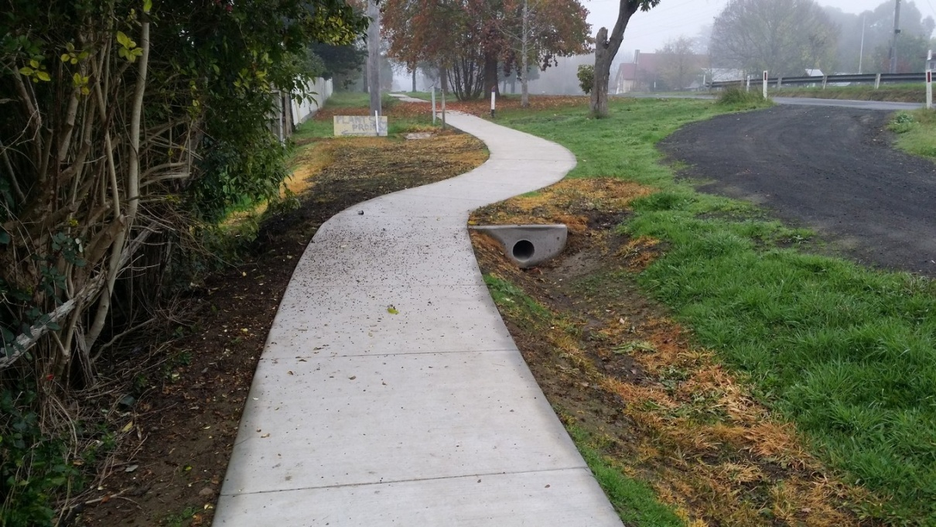
Grant Street Forrest Footpath

Footpath
The footpath was constructed of 125mm thick Green Star 3 Rated Concrete. This concrete contains a high proportion of slag, manufactured sand and recycled water as well as Eco-Reo™ reinforcing.

Car Park
The car park has a granular pavement with an asphalt wearing surface. No sustainable elements were applied to this part of the works.
An attempt was made to reuse some of the existing granular material however when excavated it proved to be of poor quality and mixed with the clay subgrade and only 5m³ was able to be reused.

Key Performance Indicators
The same Key Performance Indicators (KPIs) were applied to this project as for the Steampacket Place Project.

Sustainable Infrastructure Checklist
The Sustainable Infrastructure Checklist was completed and an overall rating of 2 stars out of 5 was achieved. The low rating occurs because some items in the checklist had the potential, in an ideal situation, to be included in the project but were not. From practical and cost considerations there is always going to be a limit on the number of sustainability enhancements that can be considered in a project of this type.

Carbon Footprint
The carbon footprint of the project was compared with a “conventional” design.
A summarised comparison of the alternative and conventional mixes is provided in Table 8, with the resultant carbon emissions shown in Table 9.
Table 8: Concrete Mix Comparison
 | Green Star | Conventional
Cement | Quantity (kg/m³) | Quantity (kg/m³)
GP Cement | 150 | 310
Slag | 100 | 0
Aggregates | Quantity (kg/m³) | Quantity (kg/m³)
Natural | 1620 | 1904
Waste Sand | 284 | 0
Table 9: Concrete Emissions Comparison
 | Low Carbon Concrete | Conventional Concrete
Concrete | Emissions (kgCO₂) | Emissions (kgCO₂)
Cementitious Material | 19060 | 26290
Natural Aggregates | 1980 | 3538
Recycled Aggregates | 1160 | 0
Reinforcement Bar | 2480 | 2610
TOTAL | 24680 | 32438

Cost Analysis
The quoted price for this project was $103,401. The Contractor advised that the rate for the concrete would decrease by $2/m² for the low carbon concrete, and $4/m² for the curing. Therefore the conventional design was estimated to cost $100,395.

Constructability
The low carbon concrete had identical construction methodology in terms of plant and equipment required, however it did require wet curing for 7 days to mitigate against dusting up and cracking.

Availability of Materials
The footpath works at Colac were procured through a standard tendering process and a number of tenderers expressed concerns about sourcing the low carbon concrete. The successful Contractor advised that he had no difficulties sourcing the Green Star 3 Rated Concrete. This suggests that there is some industry resistance to the use of these alternative materials.

Use of Sustainable/Alternative Materials
The percentage use of sustainable/alternative materials in the footpath construction is summarised as follows:
- The proportion of Slag in the Green 3 Star concrete reduces the GP cement content by 52%
- The manufactured sand in the Green 3 Star concrete reduces the amount of virgin aggregates in the concrete by 14.9%

Net Flora Increase
No net Flora increase was achieved for the project.

Maintenance
No additional maintenance requirements or costs are anticipated for this project. The low carbon concrete is expected to perform identically to conventional GP concrete.

Appearance/aesthetics
The final concrete finish was inspected in June 2014 and no cracking or defects were observed. This is a positive outcome for a concrete mix that had a large slag component.

Findings
The overall carbon emissions were reduced by 7,800kgCO₂ when the sustainable design was implemented and the overall cost was increased by $3,006. There did appear to be some industry resistance to the use of the Green Star Concrete and a lack of understanding of the objective behind its use.

Foamed Bitumen Asphalt

Background
Geelong City Council utilised FoamMix Recycled Asphalt for pavement rehabilitations projects at Grange Park Drive, Waurn Ponds and Townsend Rd, Moolap.
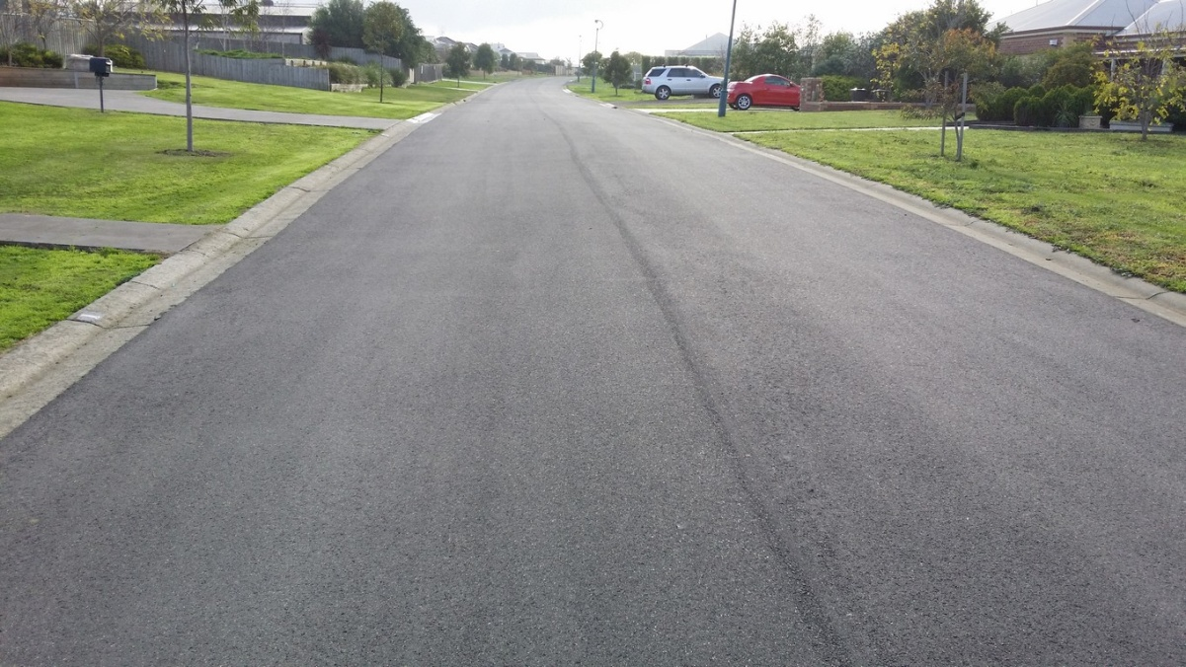
Pavement Rehabilitation – Waurn Ponds

Description of Works
Both pavements were in need of rehabilitation due to visible pavement defects caused by a weak subgrade and heavy vehicles. The sustainable treatment that was proposed was pavement reconstruction using FoamMix as a stabilised base layer followed by an asphalt seal.
The FoamMix treatment produces a bound pavement with increased stiffness and achieves this by stabilising the existing material rather than increasing the pavement thickness with new material.

Pavement
The FoamMix consists of 95% recycled materials and foamed bitumen which are combined using specialized equipment.
The process involves excavating the old pavement to a depth of 200mm, collecting the material and stockpiling it. The material is processed through a recycler which combines the reclaimed material with a foamed bitumen mixture. The FoamMix asphalt is then returned to the site and spread and compacted.

Key Performance Indicators
The Key Performance Indicators (KPI) used for the previous two projects were also used for this project.

Sustainable Infrastructure Checklist
The Sustainable Infrastructure Checklist was completed for this project and an overall rating of 5 stars out of 5 was achieved.

Carbon Footprint
The carbon footprint of the project was compared with a “conventional” design without sustainable elements.
The conventional treatment proposed by City of Greater Geelong was to excavate 330mm below the road surface and replace the pavement with two 150mm fine crushed rock layers and a 30mm asphalt wearing course.
The FoamMix stabilisation treatment option is different to the reconstruction as it reuses the excavated base course. The excavated gravel is mixed with Foamed Bitumen to increase the stiffness of the material. Due to this increase in stiffness, the layer is thinner than the granular pavement proposed in the reconstruction option.
Table 10: Pavement Type Emissions Comparison
 | Foam Mix | Conventional Flexible Pavement
 | Emissions (kgCO₂) | Emissions (kgCO₂)
Asphalt | 63819 | 63819
Foamed Bitumen Asphalt | #info from road stone
Aggregates |  | 32130
TOTAL | 85092 | 117222

Cost Analysis
The contractor quoted both jobs at a square metre rate which included the 30mm of asphalt and FoamMix. For cost comparison purposes City of Greater Geelong provided a square metre rate for a similar job that used the conventional reconstruction option.
For both Grange Park Drive and Townsend Rd, the subgrade was found to be of poor quality after excavation of pavement material and not capable of withstanding construction equipment movements and therefore was stabilised with lime to provide a suitable working platform. Even allowing for this additional cost the foam mix option is still cheaper than the granular pavement replacement. The cost comparison summarised in Table 11 below.
Table 11: Pavement Type Cost Comparison
 |  |  | Rate (/m²)
 | Area |  | No SG Stab. | SG Stab
Grange Park Drive | 2100m² |  | $73 | $120
Townsend Road | 1696m² |  | $63 | $120
Pizer St | 883m² |  | $172 | n/a

Constructability
Strength of the existing subgrade was a problem in both projects. After the existing pavement had been excavated there was only 80mm of gravel overlying the subgrade and it was unable to support the truck loads required to place the Foam Mix and may have also become a problem for compaction of the Foam Mix. In both trials the subgrade was stabilised with lime to achieve adequate strength. Following placement the pavement was prepared for asphalt surfacing and could be driven on the same day.

Availability of Materials
FoamMix was readily available from a local supplier. The process can be carried out at a fixed plant or by using a mobile recycling plant, provided there is a suitable working area and stockpile site adjacent to the project.

Design Initiatives
The FoamMix process maximises the reuse of pavement materials. Pavement re-use is one of the fundamental principles of the Sustainable Infrastructure Guidelines and a key consideration at the design stage when considering pavement rehabilitation.

Use of Sustainable/Alternative Materials
FoamMix is essentially a cold mix process and, compared with conventional asphalt, manufacturers claim that carbon emissions are approximately 50% lower.

Maintenance Costs
Maintenance costs of the pavement are expected to be similar to a full pavement reconstruction

Findings
The overall carbon emissions were reduced by 22,130kgCO₂ when the sustainable design was adopted. The overall cost was reduced by $52/m² compared with a conventional reconstruction.
Some constructability issues were encountered when soft subgrade material was uncovered during construction which led to additional unplanned subgrade improvement works. Accounting for the subgrade stabilisation the overall cost was still lower than conventional reconstruction.

Conclusions
The case studies were fairly narrow in scope and projects were required to fit in with existing infrastructure. Therefore sustainable opportunities were limited and projects were heavily focussed on material substitution rather than a complete sustainable design. Carbon emission savings of 5 to 22 tonnes were realised across the case studies.
Referring to the aims of the Sustainable Infrastructure Guidelines outlined at the start of the paper we can assess whether adoption of the various initiatives has resulted in those aims being met.
- Using recycled materials – achieved for all projects
- Reducing the carbon footprint of infrastructure projects – achieved for all projects
- Reducing maintenance and operating costs – not achieved for any of the projects as maintenance and operating costs largely unchanged
- Utilising water in more efficient ways – achieved at Steampacket Place but not achieved at Grant Street or the pavement rehabilitation projects
- Utilising materials from sustainable sources – achieved for all projects

